COMPLAINT MANAGEMENT SYSTEM

PRESENTED BY

KABILAN.K

AJITHKUMAR.M

ARUN KUMAR.T

Abstract:

A Complaint Management System is one of latest productivity enhancement tools used widely by all organizations] wherever there is a need of booking of

complaint via operator and analysis of complaints which are made or are pending. Our website C2C.com is an online complaint management system where the issues of the customers can be registered online and resolved by the different levels of engineers. Also flexibility is provided to the customers can easily resolve their issues by communicating with engineer over internet. C2C.com is a website that acts as a bridge between customer and company in which customer directly register their complaint to company via internet. Lack of paper movements provides complaint management operations a speed which was never envisaged in manual mode at all. Website allows customer to register complaint and automatically schedules and prompts operators to source complaint to concerned departments.

INTRODUCTION:

● The project is aimed at creating efficient software portal for creating addressing of the students/faculty members for various purpose like -- problem in class, projector problems, plumbing in hostels, electricity issues, other & class related problem etc.

**COMPARISION OF EXISTING SYSTEM:**

The current scenario there is very less

system operating for registration of

complaints.

Presently complaint register process

is done through telephone where a

complaint is raised by calling the

admin .

This requires a manual effort and can

lead to confusions for the student.

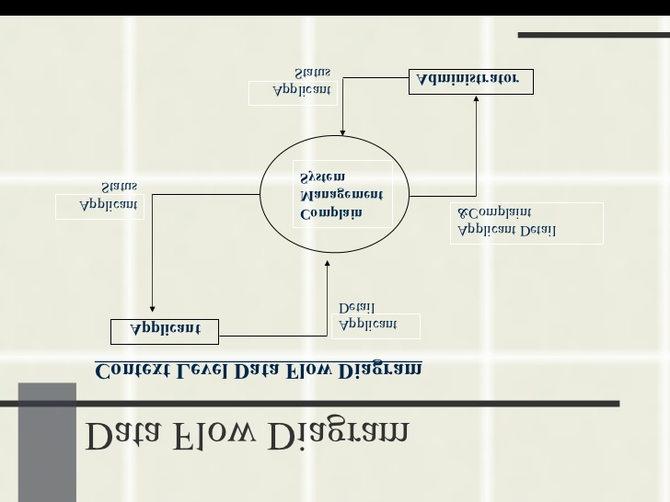





CONCLUTION:

* First of all a management system which consists of multiple administrators should be available on-line.
* The software lacks inbuilt update management for fixing bugs and adding additional feature in the future.

REFERENCE:

. BS 8600:1999 Complaints Management Systems- Guide to Design and Implementation. England, British Standards Institute. Chung -Herrera, B. G., N. Goldschmidt, et al. (2004). "Customer and Employee Views of Critical Service